**YEAR 11 ATAR CHEMISTRY – Unit 1**

**TEST 2**

**Atomic Structure and Bonding**

**Recommended time: 60 minutes**

Name: ___________________________________________________

|  |  |
| --- | --- |
|  | Total Marks |
| Part 1 & 2 | /40 |
| Part 3 | /10 |

Teacher: __________________________________________________

This test is in two parts.

**Part 1:** MULTIPLE CHOICE style test consisting of FIFTEEN (15) questions.

Each question is worth one mark.

Write your answers in the Multiple Choice Answer Sheet.

Attempt ALL Questions

**Part 2:** SHORT ANSWER questions worth a total of 25 marks.

Write all answers in the spaces provided on this sheet.

The marks allocated to each question are shown.

Attempt ALL Questions

**Part 3:** EXTENDED RESPONSE one question worth a total of 10 marks.

Write all answers in the spaces provided on this sheet.

MULTIPLE-CHOICE ANSWER SHEET

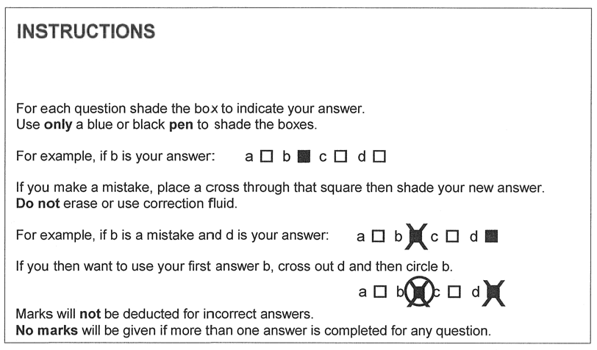

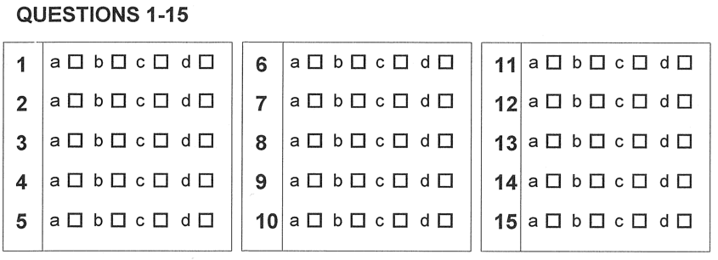

PART TWO: SHORT RESPONSE (25 marks)

________________________________________________________________________

1.

|  |  |
| --- | --- |
| protons |  |
| neutrons |  |
| electrons |  |

a.

b. __________________________________________________________

c. ­­­­­­­­­­­­­__________________________________________________________

(3 marks)

2.

a. ­­­­­­­­­­­­­__________________________________________________________

1. _______________________________________________________________
2. _______________________________________________________________
3. answer ________________________________________________________

explanation  
_______________________________________________________________  
_______________________________________________________________

_______________________________________________________________

_______________________________________________________________

_______________________________________________________________  
 (6 marks)

3.

|  |  |  |  |
| --- | --- | --- | --- |
|  | Symbol | Name | Bonding type |
| a) |  |  |  |
| b) |  |  |  |
| c) |  |  |  |
| d) |  |  |  |
| e) |  |  |  |
| f) |  |  |  |

1. marks)

4.

|  |  |  |
| --- | --- | --- |
|  | Species | Electron Dot Diagram |
| a) |  |  |
| b) |  |  |
| c) |  |  |

(3 marks)

|  |  |
| --- | --- |
|  | |
|  | |
|  | |
|  | |
|  | |
|  | |
|  | |
| Diagrams | |
|  |  |

1. Explanation
2. marks)

|  |
| --- |
|  |
|  |
|  |
|  |
|  |
|  |
|  |
|  |

(3 marks)

PART THREE: EXTENDED RESPONSE (10 marks)

________________________________________________________________________

Rutherford

|  |
| --- |
| Experiment |
|  |
|  |
|  |
|  |
|  |
|  |
| Contribution |
|  |
|  |
|  |
|  |
|  |
|  |
| Diagram |
| Thomson |
| Experiment |
|  |
|  |
|  |
|  |
|  |
|  |
| Contribution |
|  |
|  |
|  |
|  |
|  |
| Diagram |

Score: _________

10

WORKING OUT SPACE ____________________________________________________________________________________________________________________________________________________________________________________________________________________________________________________________________________________________________________

______________________________________________________________________________________________________________________________________________________

______________________________________________________________________________________________________________________________________________________

______________________________________________________________________________________________________________________________________________________

______________________________________________________________________________________________________________________________________________________

______________________________________________________________________________________________________________________________________________________

______________________________________________________________________________________________________________________________________________________

______________________________________________________________________________________________________________________________________________________

______________________________________________________________________________________________________________________________________________________

______________________________________________________________________________________________________________________________________________________